Recorded Steps

This file contains all the steps and information that was recorded to help you describe the recorded steps to others.
Before sharing this file, you should verify the following:
- The steps below accurately describe the recording.
- There is no information below or on any screenshots that you do not want others to see.
Passwords or any other text you typed were not recorded, except for function and shortcut keys that you used.
You can do the following:
- Review the recorded steps
- Review the recorded steps as a slide show
- Review the additional details

Steps

Next
Step 1: (‎05/‎10/‎2024 21:16:13) User left click on "Manage Jenkins (link)" in "Dashboard [Jenkins] - Google Chrome"
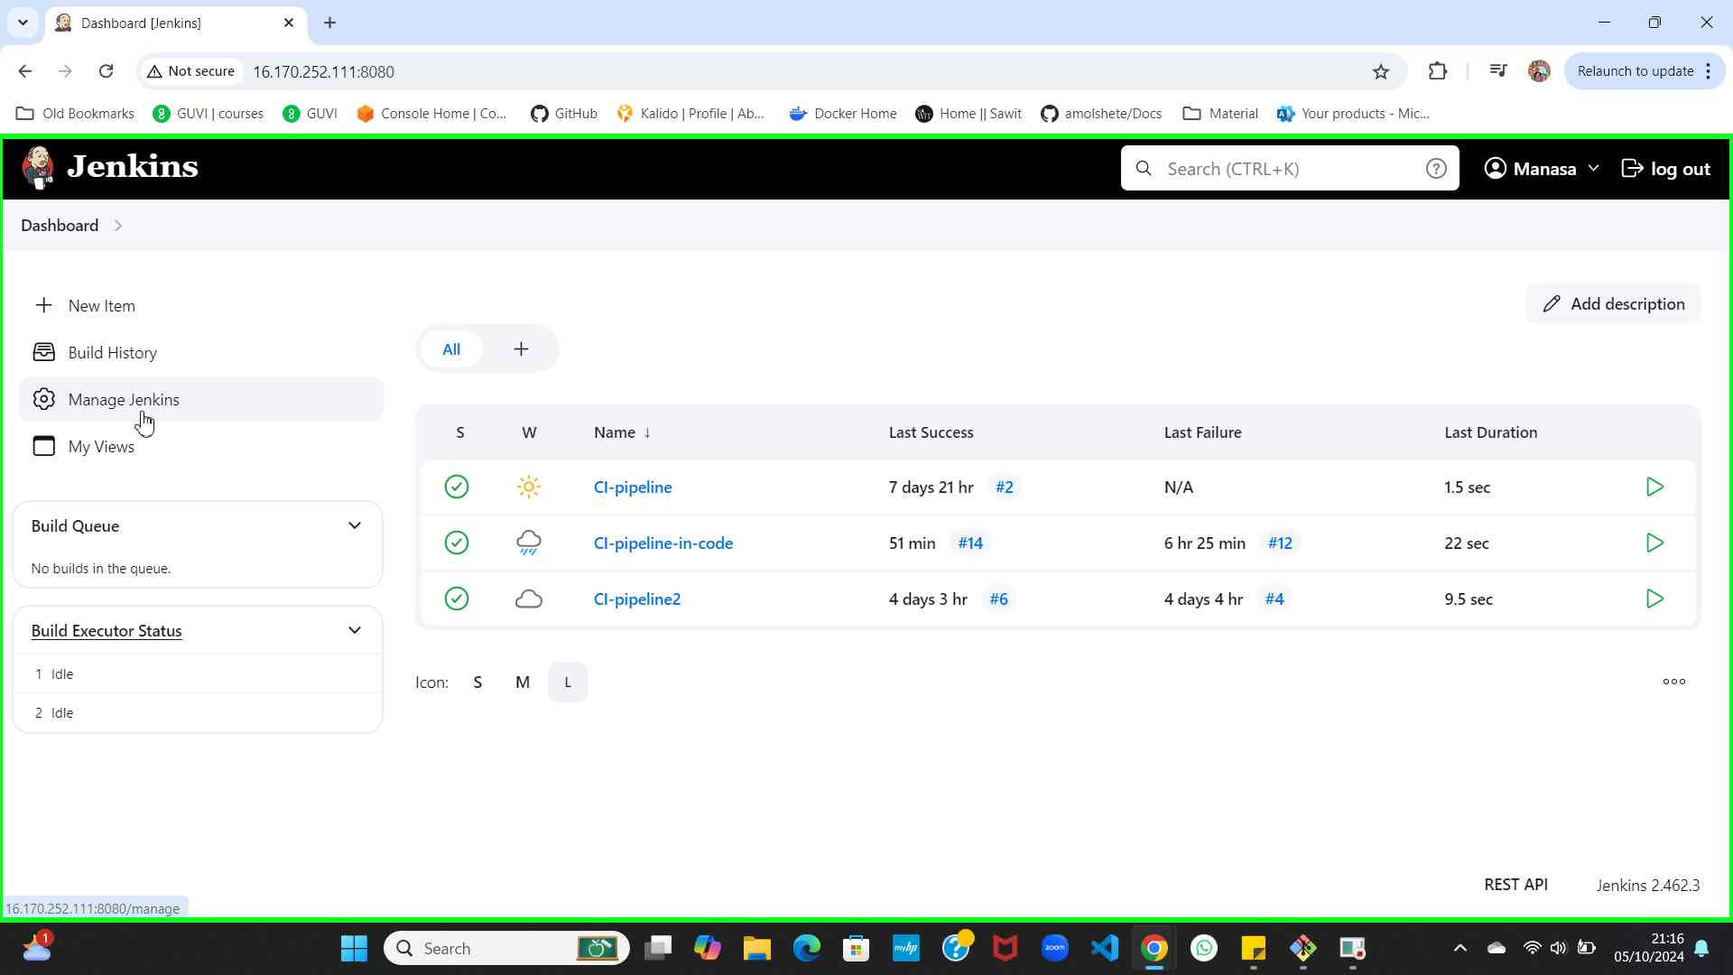Step 1 screenshot.

Previous Next
Step 2: (‎05/‎10/‎2024 21:16:43) User keyboard input on "Manage Jenkins [Jenkins] - Google Chrome (pane)" in "Manage Jenkins [Jenkins] - Google Chrome" [DOWN DOWN DOWN]
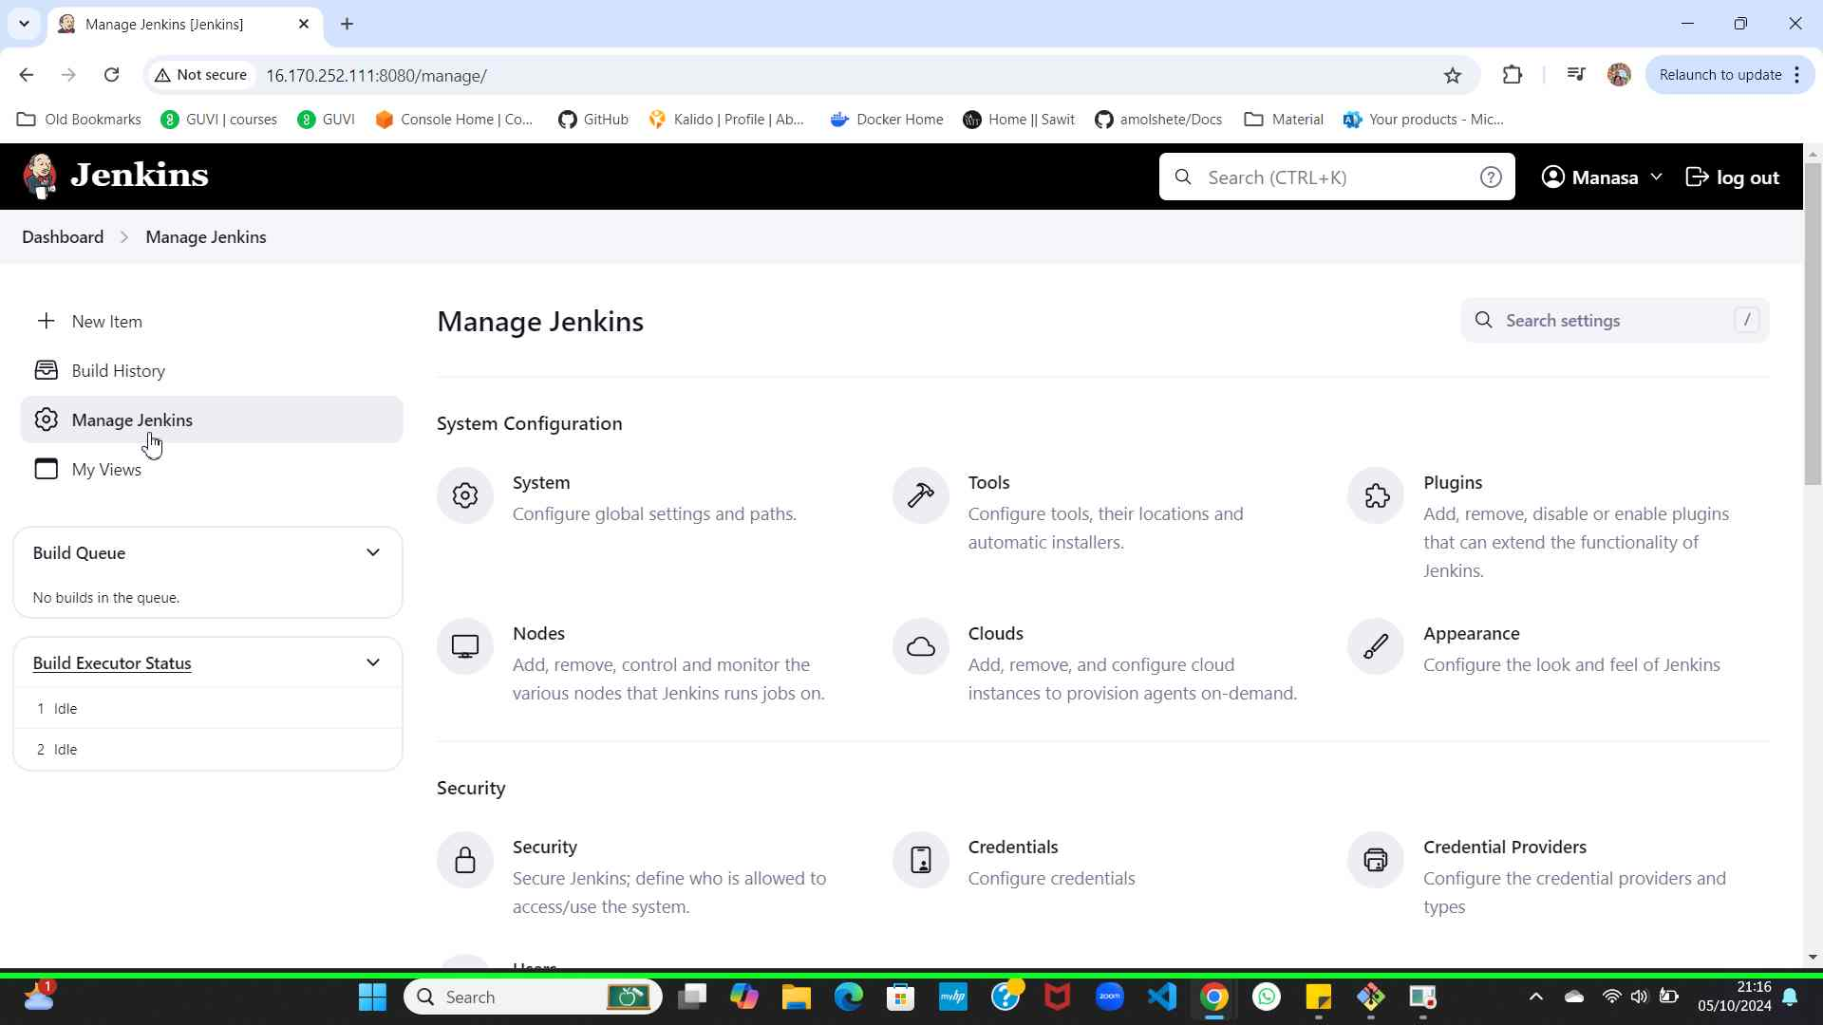Step 2 screenshot.

Previous Next
Step 3: (‎05/‎10/‎2024 21:16:46) User left click on "Create/delete/modify users that can log in to this Jenkins. (text)" in "Manage Jenkins [Jenkins] - Google Chrome"
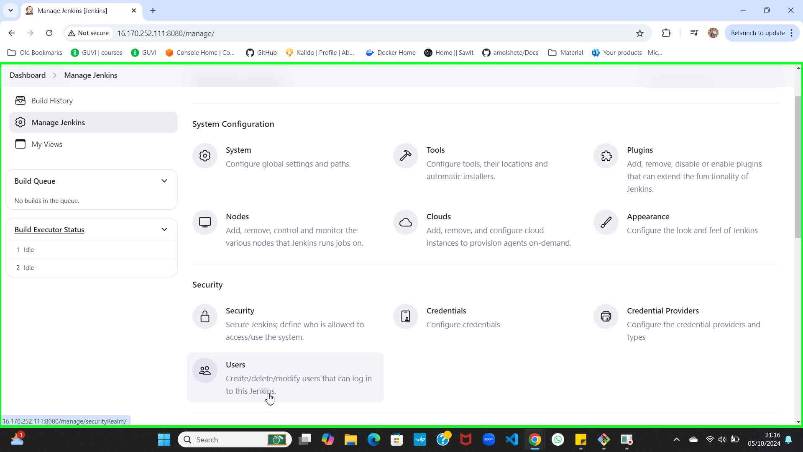Step 3 screenshot.

Previous Next
Step 4: (‎05/‎10/‎2024 21:17:11) User left click on "Users [Jenkins] (document)" in "Users [Jenkins] - Google Chrome"
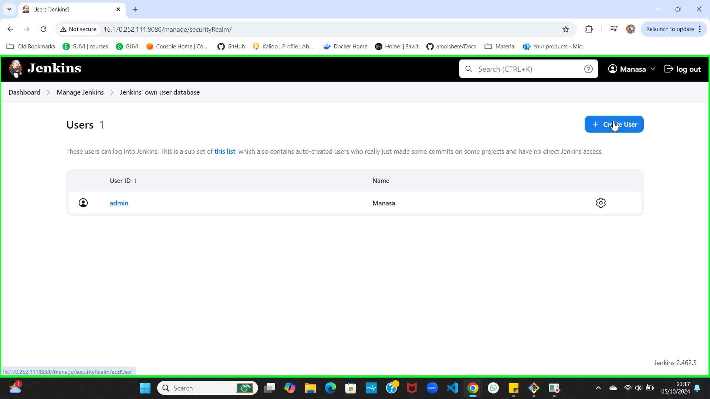Step 4 screenshot.

Previous Next
Step 5: (‎05/‎10/‎2024 21:17:35) User keyboard input on "Create User [Jenkins] - Google Chrome (pane)" in "Create User [Jenkins] - Google Chrome" [... TAB ... TAB ... TAB ... TAB ...]
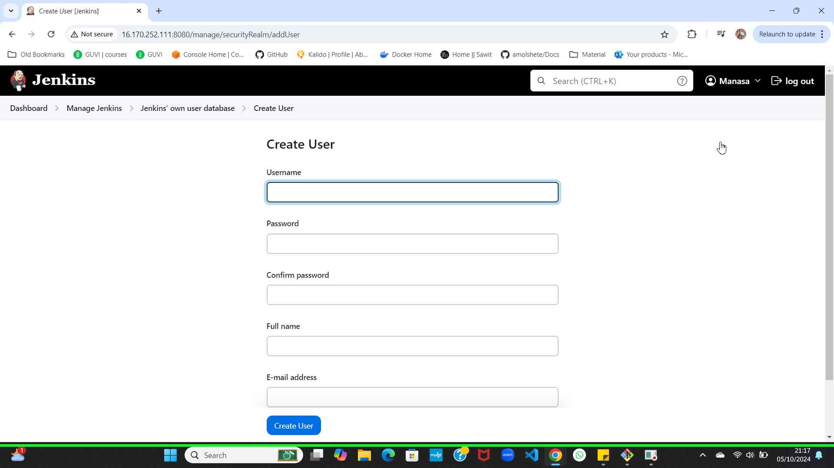Step 5 screenshot.

Previous Next
Step 6: (‎05/‎10/‎2024 21:17:59) User left click on "Create User (button)" in "Create User [Jenkins] - Google Chrome"
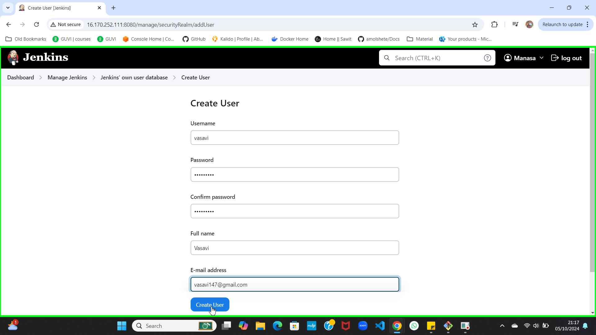Step 6 screenshot.

Previous Next
Step 7: (‎05/‎10/‎2024 21:18:23) User left click on "Users [Jenkins] (document)" in "Users [Jenkins] - Google Chrome"
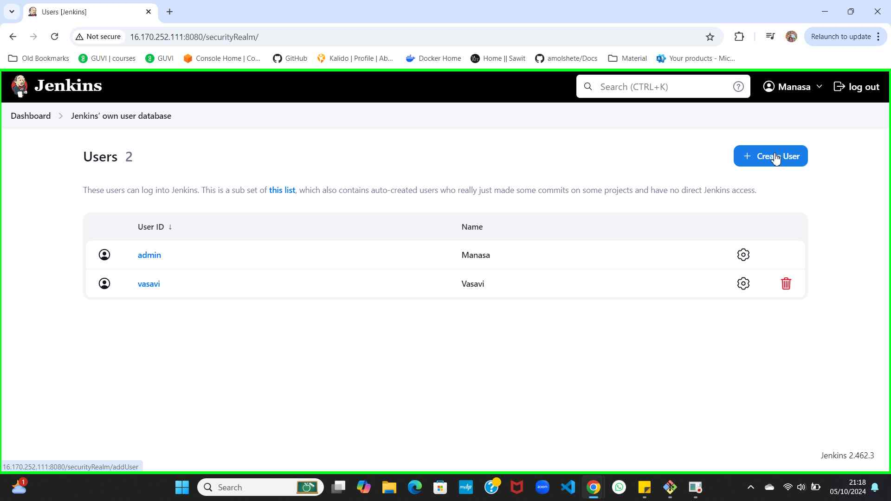Step 7 screenshot.

Previous Next
Step 8: (‎05/‎10/‎2024 21:18:48) User keyboard input on "Create User [Jenkins] - Google Chrome (pane)" in "Create User [Jenkins] - Google Chrome" [... TAB ... TAB ... TAB ... TAB ...]
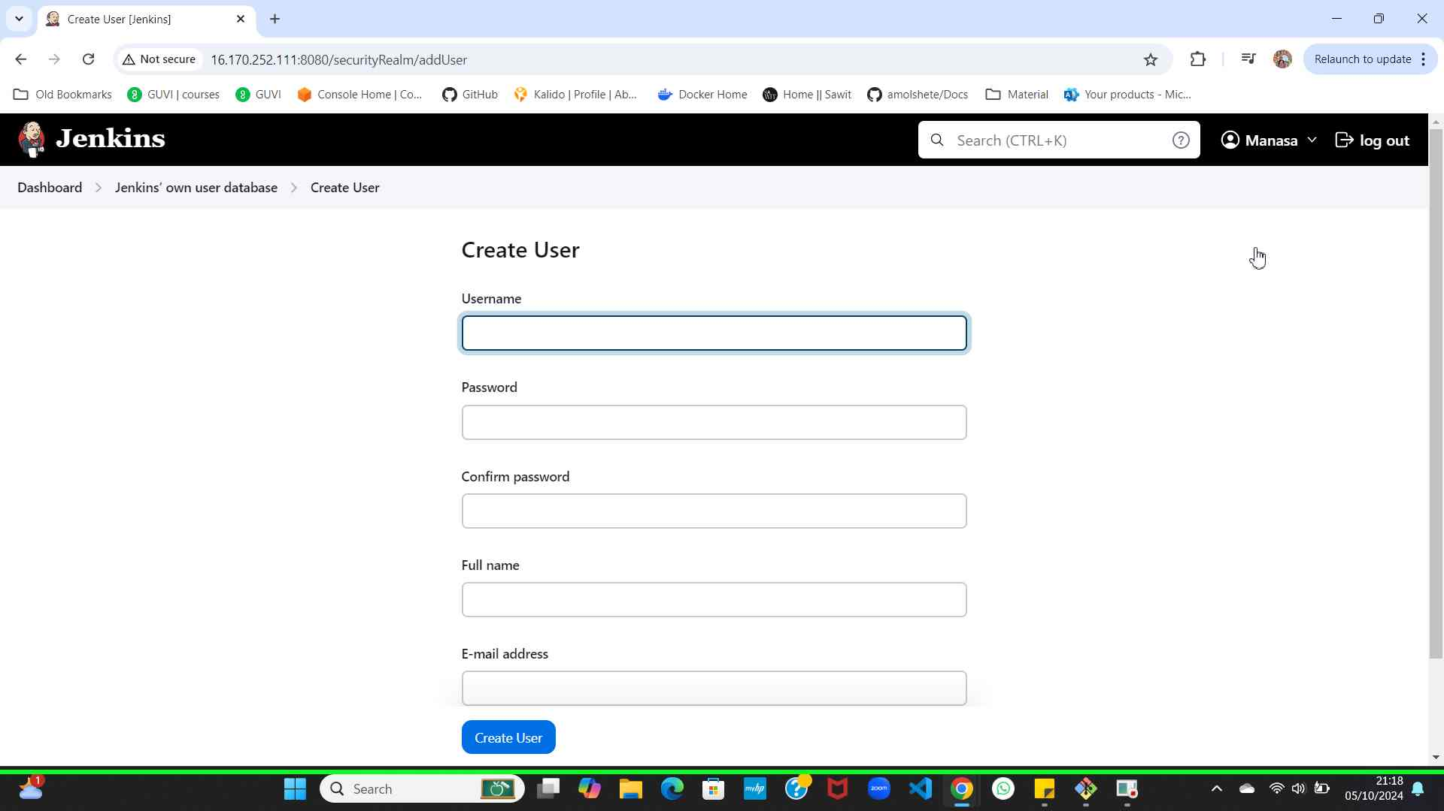Step 8 screenshot.

Previous Next
Step 9: (‎05/‎10/‎2024 21:19:08) User left click on "Create User (button)" in "Create User [Jenkins] - Google Chrome"
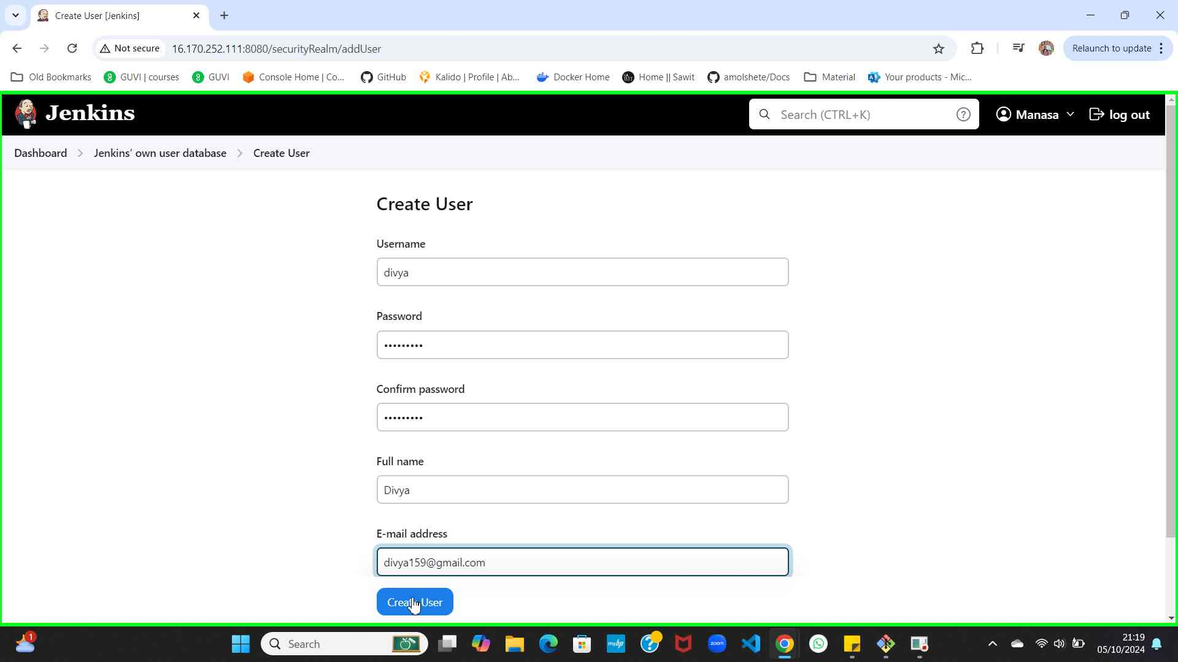Step 9 screenshot.

Previous Next
Step 10: (‎05/‎10/‎2024 21:19:34) User left click on "Users [Jenkins] (document)" in "Users [Jenkins] - Google Chrome"
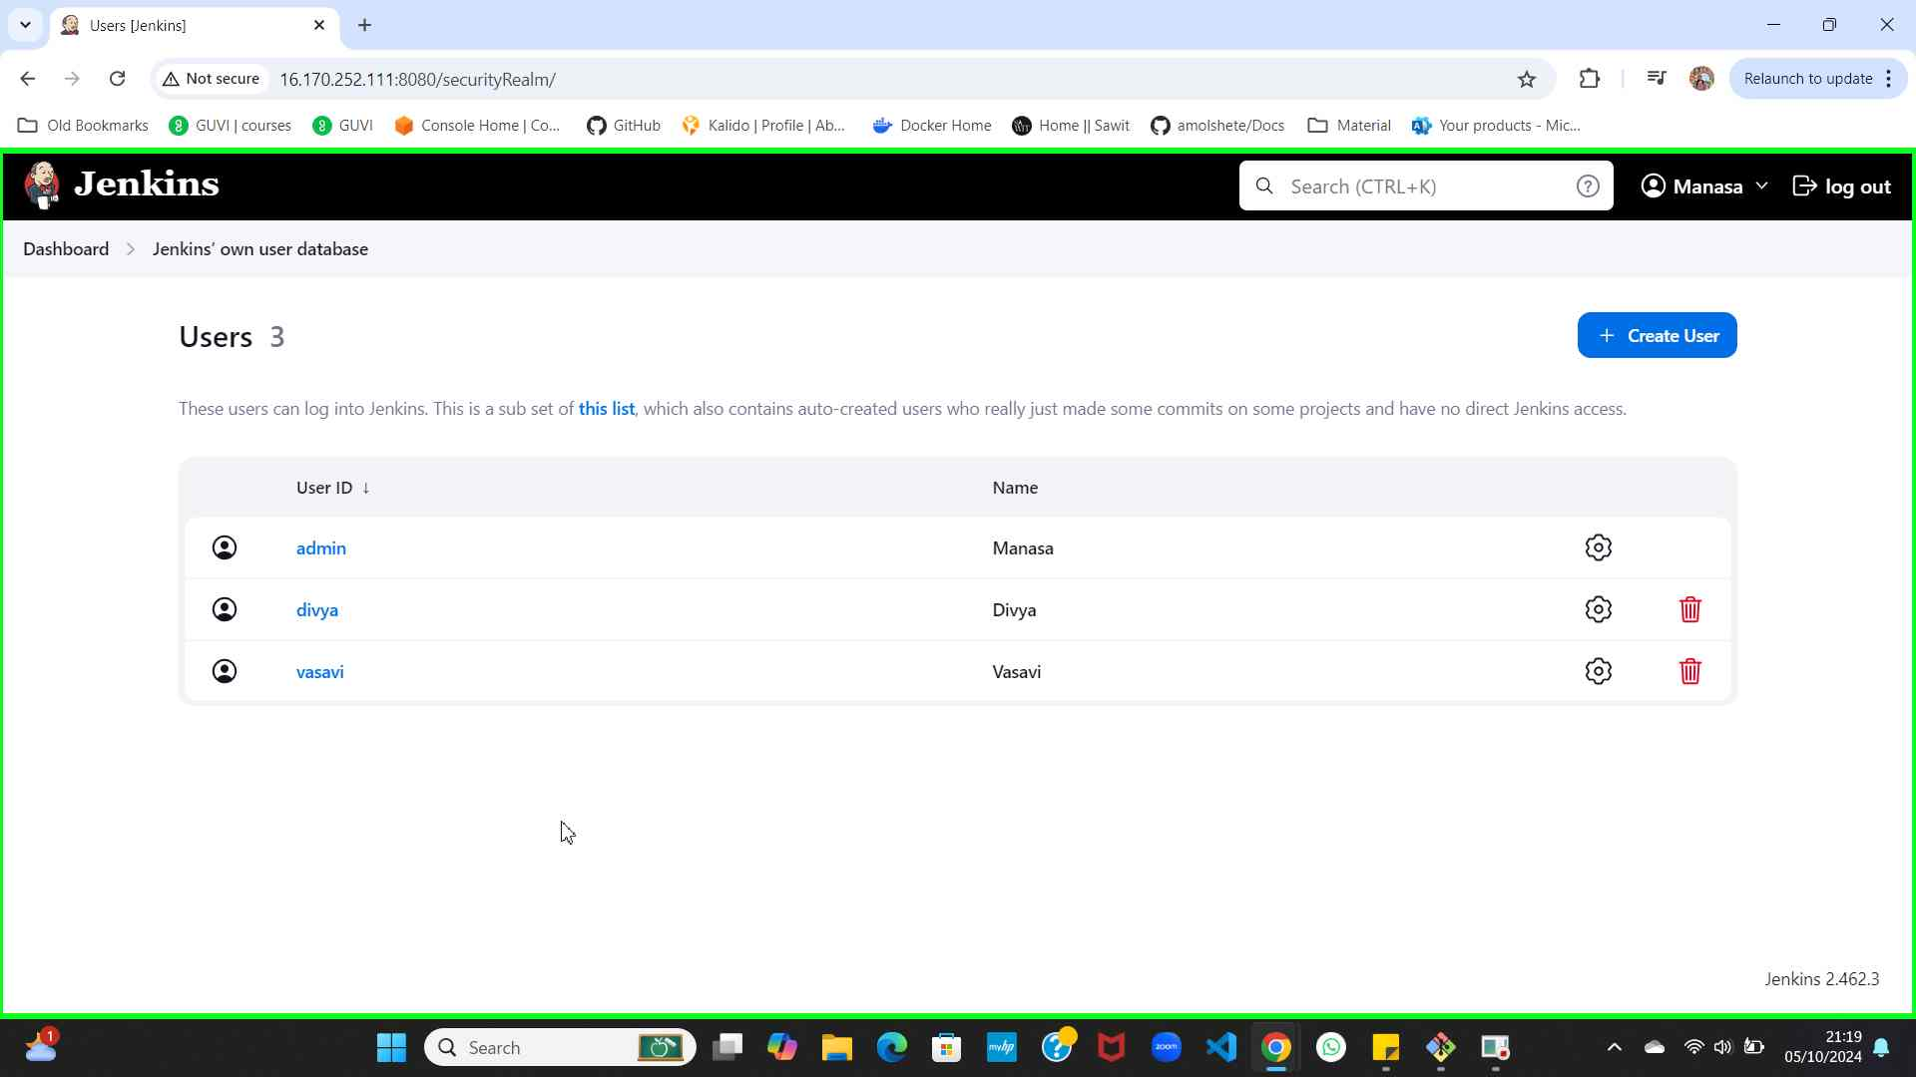Step 10 screenshot.

Previous
Step 11: (‎05/‎10/‎2024 21:19:37) User left click on "Steps Recorder - 1 running window (button)"
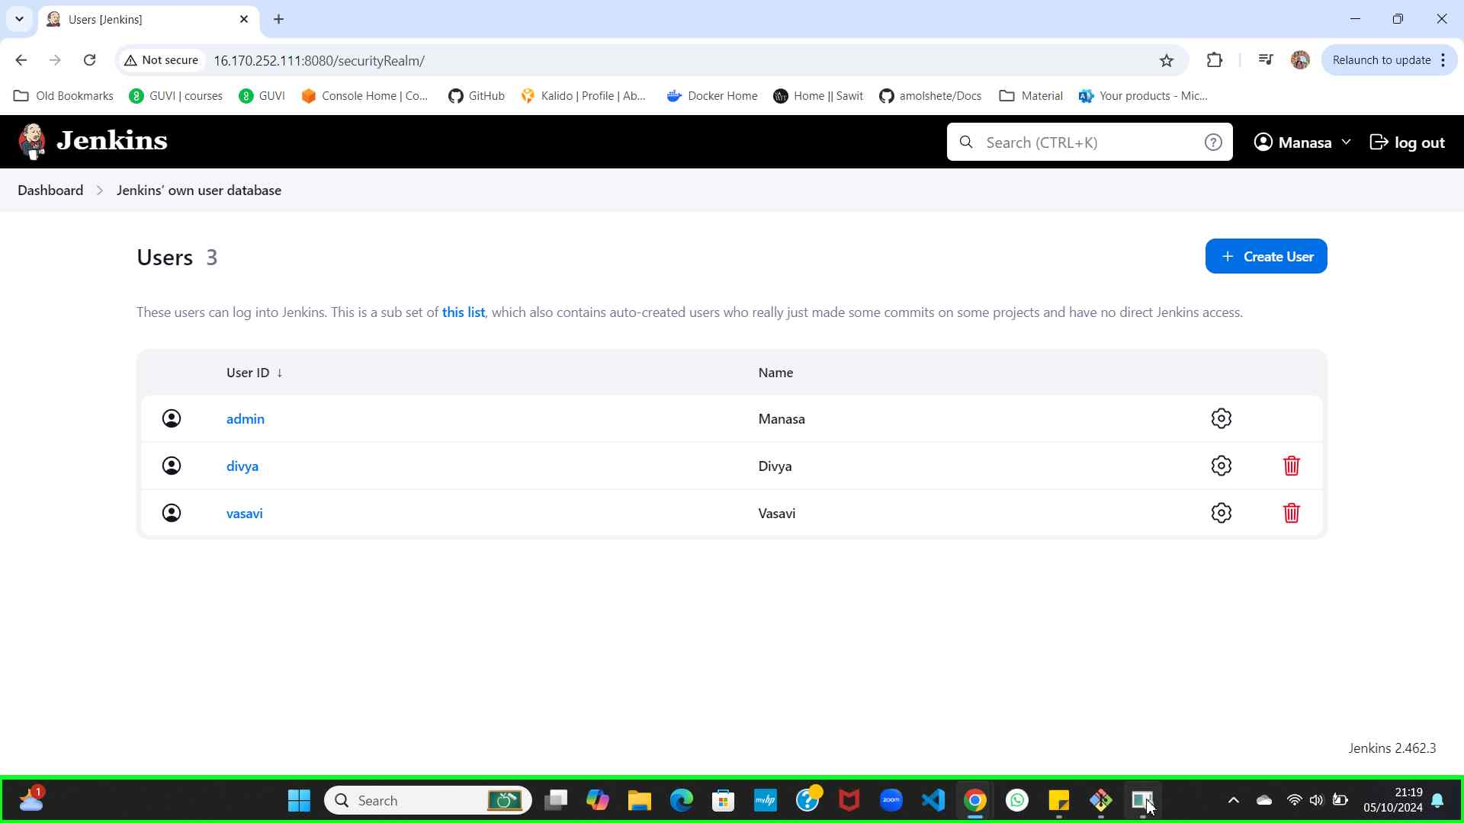Step 11 screenshot.

Additional Details
The following section contains the additional details that were recorded.
These details help accurately identify the programmes and UI you used in this recording.
This section may contain text that is internal to programmes that only very advanced users or programmers may understand.
Please review these details to ensure that they do not contain any information that you would not like others to see.

Recording Session: ‎05/‎10/‎2024 21:16:10 - 21:19:39
Recorded Steps: 11, Missed Steps: 0, Other Errors: 0
Operating System: 22621.1.amd64fre.ni_release.220506-1250 10.0.0.0.2.101
Step 1: User left click on "Manage Jenkins (link)" in "Dashboard [Jenkins] - Google Chrome"
Program: Google Chrome, 129.0.6668.70, Google LLC, CHROME.EXE, CHROME.EXE
UI Elements: Manage Jenkins, Dashboard [Jenkins], Chrome_RenderWidgetHostHWND, Dashboard [Jenkins] - Google Chrome, Chrome_WidgetWin_1
Step 2: User keyboard input on "Manage Jenkins [Jenkins] - Google Chrome (pane)" in "Manage Jenkins [Jenkins] - Google Chrome" [DOWN DOWN DOWN]
Program: Google Chrome, 129.0.6668.70, Google LLC, CHROME.EXE, CHROME.EXE
UI Elements: Manage Jenkins [Jenkins] - Google Chrome, Chrome_WidgetWin_1
Step 3: User left click on "Create/delete/modify users that can log in to this Jenkins. (text)" in "Manage Jenkins [Jenkins] - Google Chrome"
Program: Google Chrome, 129.0.6668.70, Google LLC, CHROME.EXE, CHROME.EXE
UI Elements: Create/delete/modify users that can log in to this Jenkins., Create/delete/modify users that can log in to this Jenkins., Manage Jenkins [Jenkins], Chrome_RenderWidgetHostHWND, Manage Jenkins [Jenkins] - Google Chrome, Chrome_WidgetWin_1
Step 4: User left click on "Users [Jenkins] (document)" in "Users [Jenkins] - Google Chrome"
Program: Google Chrome, 129.0.6668.70, Google LLC, CHROME.EXE, CHROME.EXE
UI Elements: Users [Jenkins], Chrome_RenderWidgetHostHWND, Users [Jenkins] - Google Chrome, Chrome_WidgetWin_1
Step 5: User keyboard input on "Create User [Jenkins] - Google Chrome (pane)" in "Create User [Jenkins] - Google Chrome" [... TAB ... TAB ... TAB ... TAB ...]
Program: Google Chrome, 129.0.6668.70, Google LLC, CHROME.EXE, CHROME.EXE
UI Elements: Create User [Jenkins] - Google Chrome, Chrome_WidgetWin_1
Step 6: User left click on "Create User (button)" in "Create User [Jenkins] - Google Chrome"
Program: Google Chrome, 129.0.6668.70, Google LLC, CHROME.EXE, CHROME.EXE
UI Elements: Create User, Create User [Jenkins], Chrome_RenderWidgetHostHWND, Create User [Jenkins] - Google Chrome, Chrome_WidgetWin_1
Step 7: User left click on "Users [Jenkins] (document)" in "Users [Jenkins] - Google Chrome"
Program: Google Chrome, 129.0.6668.70, Google LLC, CHROME.EXE, CHROME.EXE
UI Elements: Users [Jenkins], Chrome_RenderWidgetHostHWND, Users [Jenkins] - Google Chrome, Chrome_WidgetWin_1
Step 8: User keyboard input on "Create User [Jenkins] - Google Chrome (pane)" in "Create User [Jenkins] - Google Chrome" [... TAB ... TAB ... TAB ... TAB ...]
Program: Google Chrome, 129.0.6668.70, Google LLC, CHROME.EXE, CHROME.EXE
UI Elements: Create User [Jenkins] - Google Chrome, Chrome_WidgetWin_1
Step 9: User left click on "Create User (button)" in "Create User [Jenkins] - Google Chrome"
Program: Google Chrome, 129.0.6668.70, Google LLC, CHROME.EXE, CHROME.EXE
UI Elements: Create User, Create User [Jenkins], Chrome_RenderWidgetHostHWND, Create User [Jenkins] - Google Chrome, Chrome_WidgetWin_1
Step 10: User left click on "Users [Jenkins] (document)" in "Users [Jenkins] - Google Chrome"
Program: Google Chrome, 129.0.6668.70, Google LLC, CHROME.EXE, CHROME.EXE
UI Elements: Users [Jenkins], Chrome_RenderWidgetHostHWND, Users [Jenkins] - Google Chrome, Chrome_WidgetWin_1
Step 11: User left click on "Steps Recorder - 1 running window (button)"
Program: Windows Explorer, 10.0.22621.4315 (WinBuild.160101.0800), Microsoft Corporation, EXPLORER.EXE, EXPLORER.EXE
UI Elements: Steps Recorder - 1 running window, Taskbar.TaskListButtonAutomationPeer, Taskbar.TaskbarFrameAutomationPeer, Windows.UI.Input.InputSite.WindowClass, DesktopWindowXamlSource, Windows.UI.Composition.DesktopWindowContentBridge, Taskbar, Shell_TrayWnd

Return to top of page...

